Personal Learning Networks
Version 1.1
Created by Barry Avery
12th October 2011
Version 1.1
Slight changes to make it about IT

This work is licenced under the Creative Commons Attribution-NonCommercial-ShareAlike 3.0 Unported License. To view a copy of this licence, visit http://creativecommons.org/licenses/by-nc-sa/3.0/

Personal Learning Networks and Twitter

About
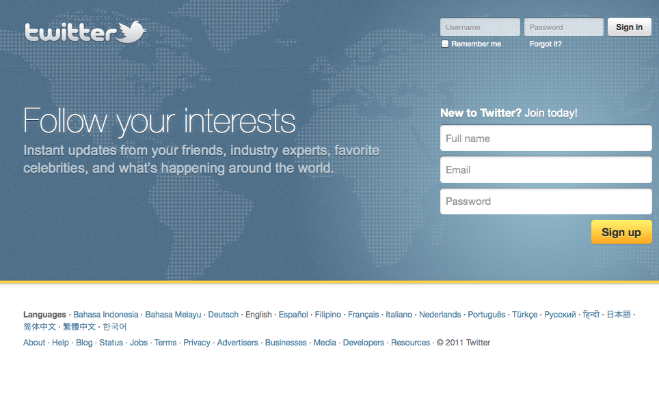
This document explains how to create a Personal Learning Network (PLN) using the Twitter service.

What is Twitter?
Twitter is a micro blogging service which allows users to post and read small updates on their own activities or things of interest.
Most people are familiar with Facebook, but there are significant differences in Twitter – all posts are limited to 140 characters and are in the public domain. Despite this, Twitter is one of the fastest growing social services, with hashtags being seen widely in the media and full integration appearing in mobile devices (such as in iOS5 – the Apple operating system for iPhones and iPads).
Twitter can be used as a straight replacement for Facebook, but many people are using it to promote themselves, their own professional interests and to follow people who are prominent in a particular field (creating a personal learning network).

Creating a Twitter account
Be careful about the username and public details you supply – as with an unadministered Facebook account many of these details will be widely available for future employees to see. To address this issue, many people use two accounts, one for personal Facebook style updates and one to promote a professional image. Most of the Twitter clients available allow you to switch easily between multiple accounts.
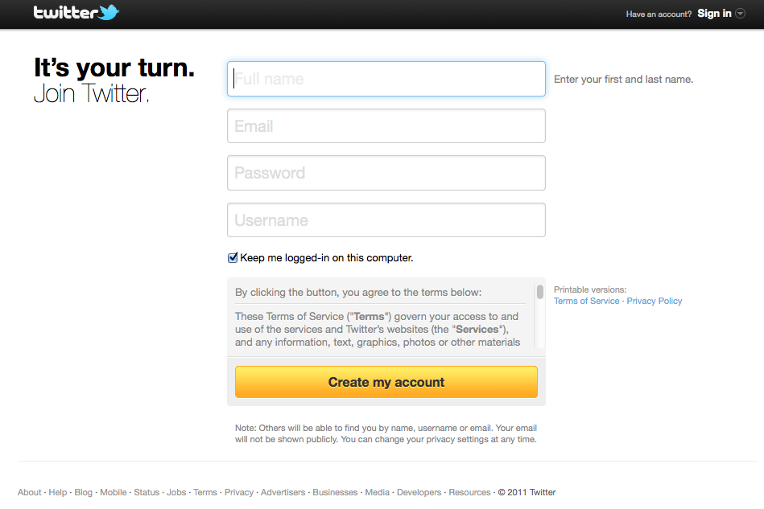
Creating a personal Twitter account
Supply enough information to indicate that it is a personal account, but not your full details in the username field (i.e. use a nickname, or your first name with a number fred2, Jane45, etc.)
Once you have signed in, you will need to follow some people – use the search box at the top of the page to find friends or celebrities who you wish to follow.
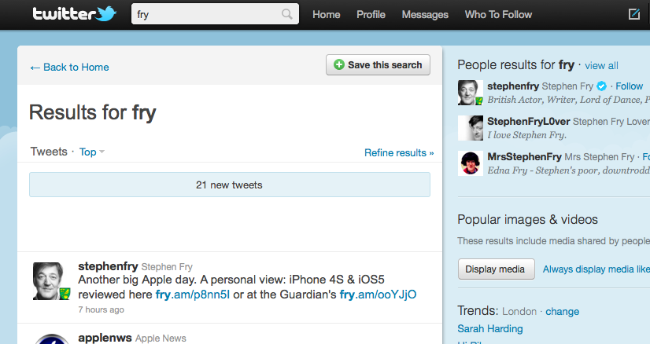
When you click on a person, you can see who follows that person and follow them if you wish.
Activity – sign up and follow at least 10 people to see how the service operates. If you are feeling brave you can post some information about yourself (this will work better if you have a few people following you and you are following them – so see if anyone else in the group is trying the activity out at the same time).
As this is a relatively anonymous account, you can be more relaxed about the nature of your posts.
Creating a professional Twitter account
Sign up for a Twitter account, but use your real name. Make sure that the details you add indicate your ‘professional nature’. Remember that all details you post here may be visible for a long time.
Find people who are microblogging (tweeting) in the areas that you are interested in – for example use the search field with the term ‘marketing’ to see a variety of people who either use marketing in their tweets on a regular basis, or have the term in their profile. Once you have found some prominent people – look to see who follows them and add them to your follow list.
To make people follow you back, you need to post things that are interesting or relevant to the network of people you have followed. Over a few days try to post links to interesting articles, web pages or photographs that align with your professional interests, with a commentary (e.g. “Interesting article about … in Computing Weekly”).

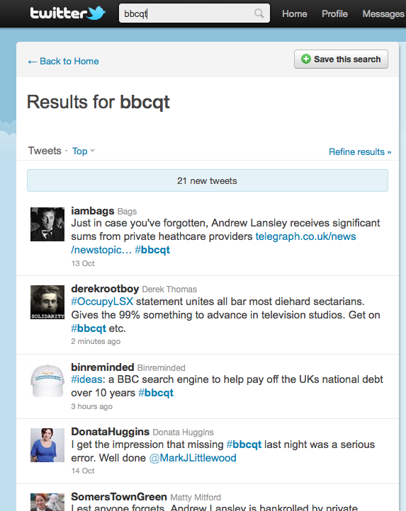
Hashtags
Hashtags are a made up series of letters/numbers preceded by a hash symbol, which are attached to a tweet to indicate that it is about a specific topic or subject area.
By searching on a particular hashtag (and then refreshing the search regularly), you can see the discussion, themes and topics being discussed around some specific focus
Conference organisers or television programmes may make up a hashtag and publicise it – alternatively users may simply make one up and start using it together.
Activity – find a popular television programme which has an active hashtag and follow the tweets whilst the programme is on (you may have to search for the programme name – the hashtag in use should then become obvious). Try programmes like Question Time, X-Factor or Strictly Come Dancing which have very popular twitter followers.

Other points to note
Retweeting is the process where a popular tweet is echoed (repeated on) – most clients have a button or interface that allow a retweet with the possibility of adding a further message
Usernames – if you wish to include a particular user in your tweet (say in a reply) use @username – this will then pop up in the ‘mentions’ part of the twitter interface
Direct Messaging – you can use twitter to send a message to a user directly but be careful – recently a government minister mistook replying (which creates a public message) to direct messaging (DM’ing)
URL shortening – including a long URL link in a tweet would use up many of the 140 characters – services such as bit.ly offer a quick and easy way to add a long URL or link in a short way

