Creating a personalised homepage with netvibes and RSS feeds
Version 1.0 – IT examples
Created by Barry Avery
15th September 2012
Derived from a similar worksheet on iGoogle
This is an alternative version of this document, which has slight changes to incorporate its use on a more IT oriented course (as opposed to the retail examples used in the original).
This work is licenced under the Creative Commons Attribution-Non Commercial-Share Alike 3.0 Unported License. To view a copy of this licence, visit http://creativecommons.org/licenses/by-nc-sa/3.0/

Creating a personalised homepage with Netvibes and RSS feeds

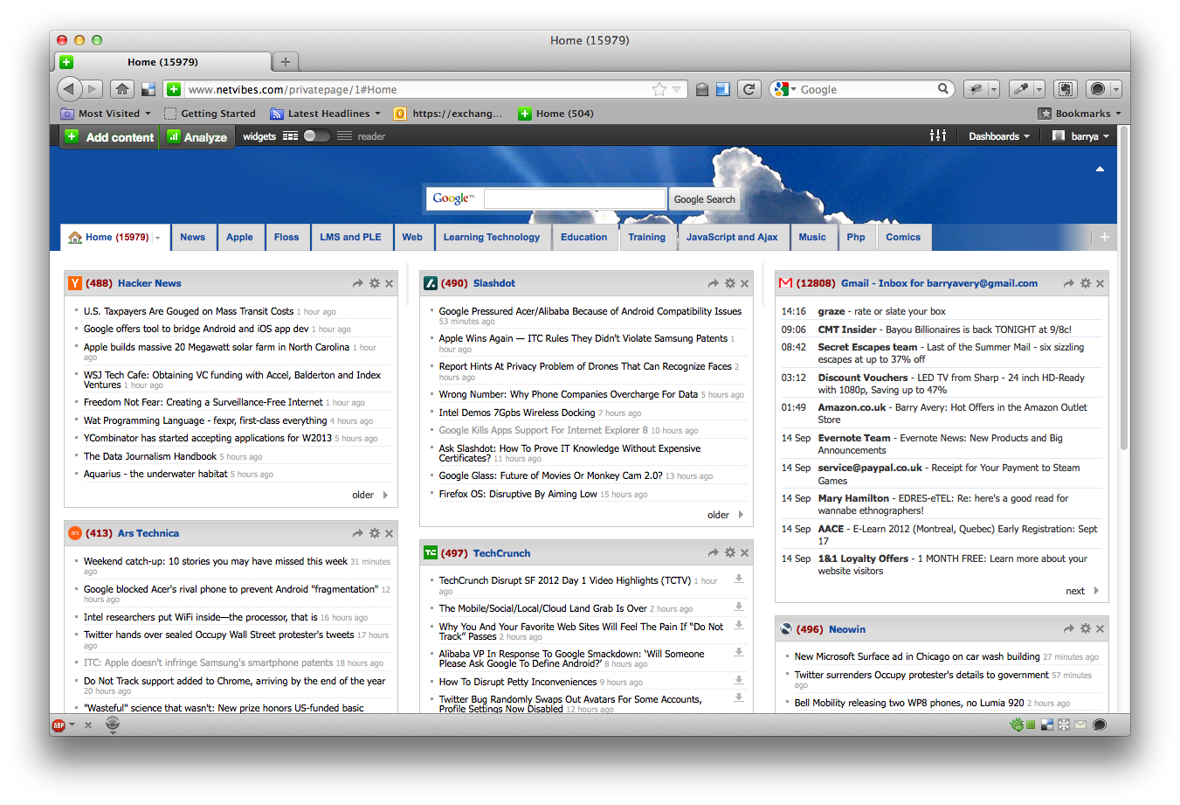
About
This activity demonstrates how to create a customised homepage, so that stories, news feeds and items of relevance are immediately pulled onto the first page that is displayed in your browser. This activity requires a Netvibes account to create a personalised homepage. Similar techniques can be applied to services offered by Microsoft – the activities specified here are specific to Netvibes.
Figure 1
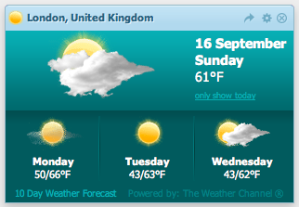

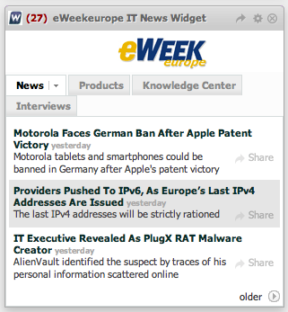
Each panel (called a module in Netvibes) is a gadget which can show information feeds as a list or using graphics. Netvibes offers a variety of default modules, or the ability to create your own modules using RSS feeds from other sites.

Note
It is the nature of Web Browser based services to change very rapidly. These screenshots were current on 15/9/2012, but it is entirely possible that the interface may differ over time.

One
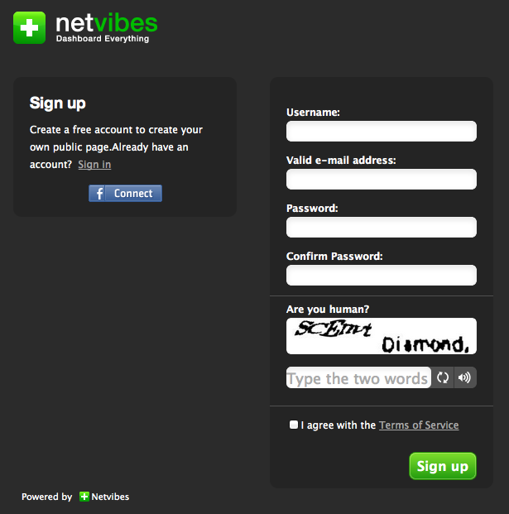
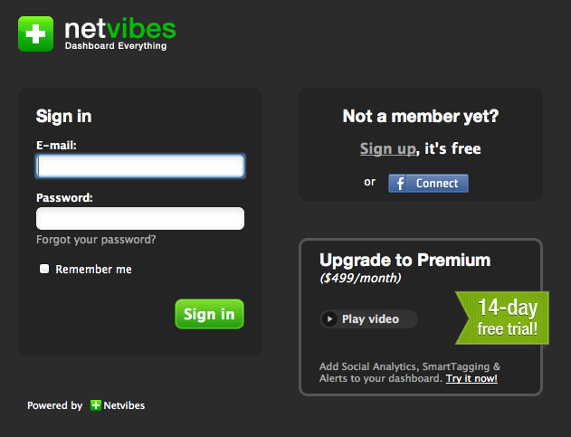
Use a modern browser to navigate to www.netbeans.com/signin (figure 2). You will need to create an account (choose the free option if asked) – you can either create an independent netvibes account with its own username and password, or link it to your Facebook account if you have one (figure 3).
Figure 3
Figure 2

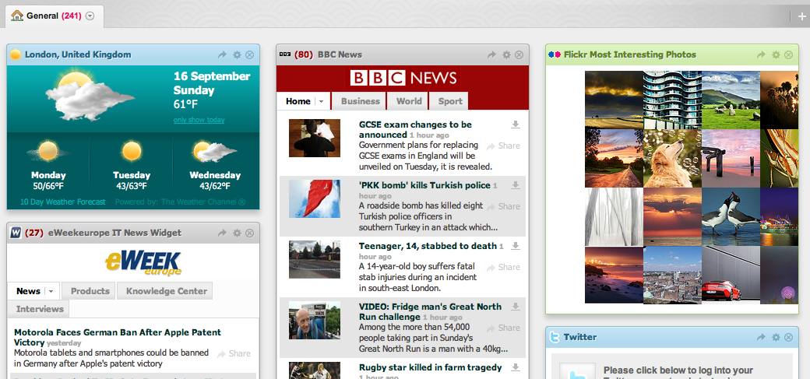
Two
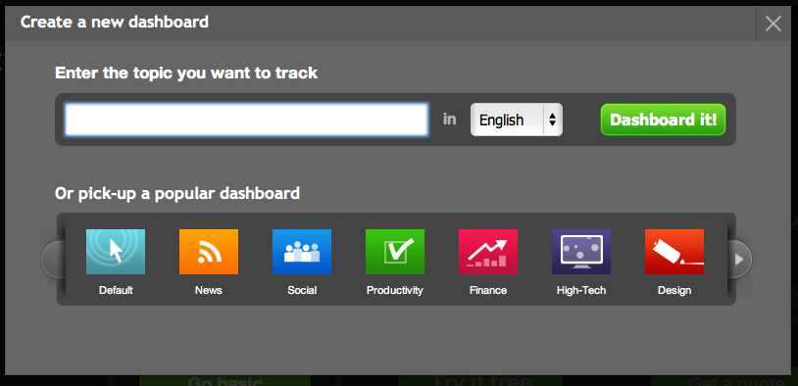
Figure 4
Figure 5
Create a new dashboard using the Default icon (figure 4). You should end up with a series of modules on the variety of subjects (your dashboard will look something like figure 5, but it may have different panels or a different layout).
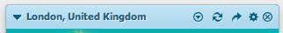
Each module (gadget or feed) on the page has its own rectangle, with a banner at the top indicating its name and a small number of icons that can be used to control the gadget (figure 6). Hover the mouse over each icon to see its purpose.
Figure 6
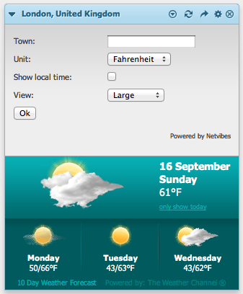
Move a module around the page by hovering the mouse over the banner and using a click and drag motion.

To see/edit the settings for a gadget or feed, use the edit cog icon – try changing the settings for the weather module to find the local weather conditions (figure 7). The other icons in the banner are for options (in the dashboard), refresh (the modules data), share (the module with another person), edit (the modules settings) and close (delete the panel).
Figure 7

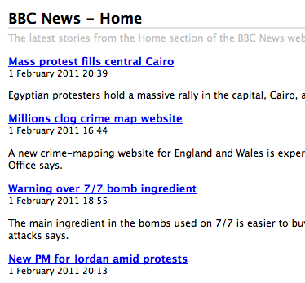
Three – adding a customised RSS feed
RSS feeds (Really Simple Syndication) are a common web feed format used on sites to export (typically) the title, a summary and a link to an original story or text piece (figure 8). Sites that support RSS use an icon (figure 9) to signify that they provide a feed that may be used to extract the content onto other sites.
RSS feeds can be used in dedicated feed reader software (that can be downloaded and installed) or online through the browser – Netvibes allows RSS feeds to be encapsulated through a module onto the personalised home page.
Figure 8
There are many ways to add a feed (the browser may force the use of one or the other of these), but in general you
- Click on the RSS link on a page and copy the URL
Figure 9
- Use the Add content button to paste the feed and create the module in Netvibes
Adding a feed for the arstechnica web site
In a new tab in the browser, navigate to http://www. arstechnica.com and look for the RSS icon. Clicking on the icon should show an option to subscribe to the feed - use the View XML feed link, and copy the URL displayed in the navigation bar (feeds will either mention XML or begin with rss:// )
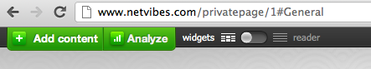
http://feeds.arstechnica.com/arstechnica/index?format=xml
Switch to the Netbeans tab in the browser and click the Add content button (figure 10).
Figure 10
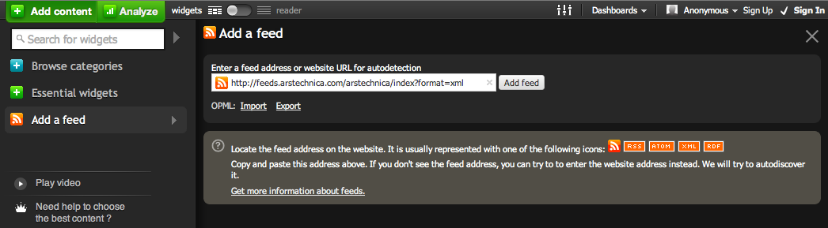
Use the Add a feed menu item and paste the link into the feed URL (figure 11).

Figure 11
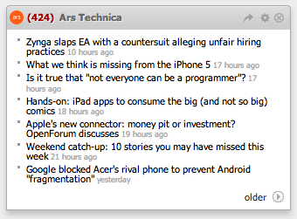
After the feed has been processed, an icon will appear which can be dragged down into the page - feed should then appear (figures 12 – 14).
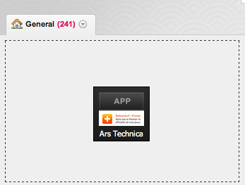
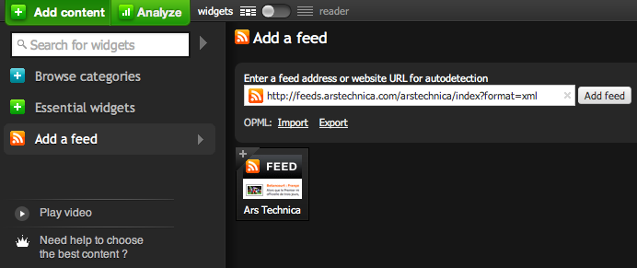
Figure 14
Figure 13
Figure 12

Exercise Add a feed for another IT news site – www.slashdot.org

Four – Organising the Netvibe tabs
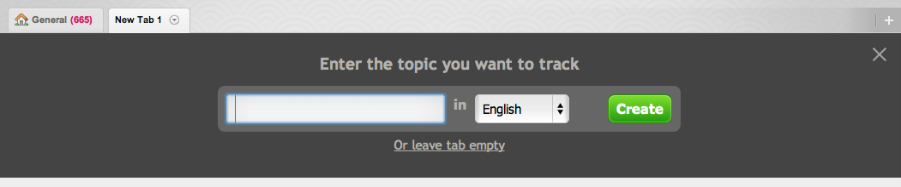
You can organise the tabs (the named labels across the top of the page), adding, renaming or deleting tabs by categories of your choice. Use the + icon to create a tab called IT News (use the leave tab empty link to create a blank tab – figure 15).
Figure 15
Move the IT based feeds off the original home tab and onto the new IT News tab by grabbing the banner at the top of the feed and dragging / dropping it onto the IT News tab.
Add feeds for two other IT sites
- http://techcrunch.com
- http://www.theregister.co.uk
Then change each of the feeds so that 9 news items are displayed in each one (hint – use edit settings in each feed individually).

Five – creating a specific RSS feed on a specific news topic
Google allows RSS feeds to be created on any stories which it indexes as part of its news search, which can be particularly useful when studying current news around some event or organisation. To do this select Google News and search for news on a particular IT subject (for example Social Network).
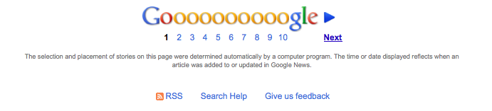
At the very bottom of the page is an RSS icon, which will turn this search into a dedicated RSS feed which can be added to your other feeds (figure 16).
Search (and add) an RSS feed for an IT subject that you wish to follow.
Figure 16

Six – add feeds for your email, facebook stream or twitter
There are modules to add feeds from your email (Hotmail, gmail), social network (Facebook) or microblogging account (twitter). Try adding these to your front tab.
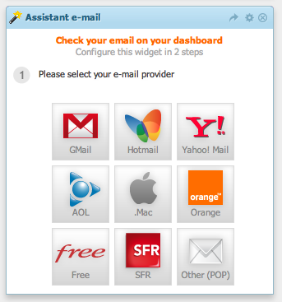
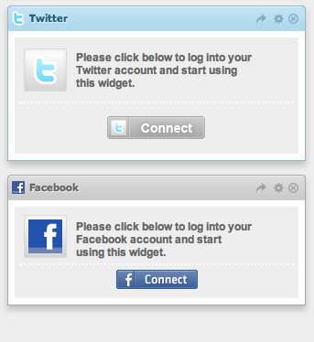

Seven – add feeds for some of these sites
General IT news sites | General Technology sites
www.slashdot.org | Guardian Newspaper Technology site
arstechnica.com | Wired
techcrunch.com
neowin.net
techdirt.com
techmeme.com

Apple technology sites | Open Source and Free technology sites
arstechnica.com/apple | linux.com
appleinsider.com | linuxtoday.com
tidbits.com | theregister.co.uk
macdailynews.com
tuaw.com

